
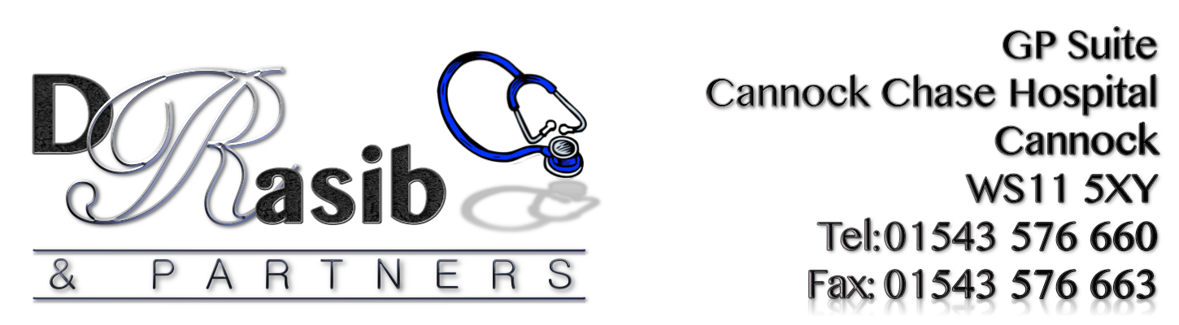

NHS FRIENDS & FAMILY TEST

“HOW LIKELY ARE YOU TO RECOMMEND OUR SERVICE TO
FRIENDS AND FAMILY IF THEY NEEDED SIMILAR CARE
OR TREATMENT?”

April 2017 RESULTS





Extremely Likely | Likely | Neither Likely/ Unlikely | Unlikely | Extremely Unlikely | Don’t Know
41 | 51 | 2 | 1 | 0 | 2

Comments Received from Patients included:
‘Whole experience very good. Receptionists always happy to help. It makes a difference’
‘Very helpful, very understanding want to thank the whole team’
‘Wonderful and helpful staff. Always ready to help and nothing too much’
‘Very Efficient Service’
‘Getting appointments is quick’
‘Friendly and polite service with knowledgeable Doctor’
‘The staff are helpful and very respectful of personal matters’
‘Always give multiple options’
‘Excellent Service’
‘Dr Rasib great doctor. Helped me and my family endlessly. Would not go anywhere else’
‘Brilliant Service’

HAVE YOUR SAY TODAY…
COMPLETE A FRIENDS & FAMILY QUESTIONNAIRE

